

**University of engineering & technology Peshawar**

**Digital Logic &computer Design-lab**

**Lab report no#03**

**Spring 2020**

**Submitted by: Ashfaq Ahmad**

**Section: B**

**Reg No: 19PWCSE1795**

**Semester: 3rd**

**“On my honor, as a student of University of Engineering and Technology Peshawar, I have neither given nor received unauthorized assistance on this academic work”**

Student signature: ____________________

**Submitted to:**

**Eng: Abdullah Hamid**

**Department Of Computer System Engineering**

**OBJECTIVE:**

After completing this experiment, you will be able to:

* Experimentally verify the De-Morgan’s theorems using two input variables

**COMPONENTS REQUIRED:**

* 7432 quad 2-input OR gate
* 7404 hex inverter
* LED
* 7430 quad 2-input AND gate
* DIP switch
* Three 1 kΩ resistors

**DE-MORGAN’S THEOREM:**

* De-Morgan theorem explains that the complement of the product of all the terms on left side is equal to the sum of the complement of each term on right side. Likewise, the complement of the sum of all the terms on left side is equal to the product of the complement of each term on right side.
* De-Morgan theorem is based on the principle of duality.
* According to De Morgan's theorem, a NAND gate is equivalent to an OR gate with inverted inputs. Similarly, a NOR gate is equivalent to an AND gate with inverted inputs. Figure shows these *De Morgan equivalent gates* for NAND and NOR gates. The two symbols shown for each function are called *duals*. They are logically equivalent and can be used interchangeably.

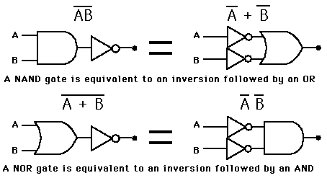

**Mathematically:**

▪ (X + Y)’ = X’ . Y’............ (a)

▪ (X . Y)’ = X’ + Y’............ (b)

* In this lab we have to prove these mathematical forms.

**PROCEDURE:**

* Build the circuit for left part of equation (a) as shown in figure 3.1 and monitor the behavior of LED for different test inputs
* Then complete the circuit of figure 3.2 for the right part of equation (a) and complete the truth table 3.1 by testing each combination of inputs of appropriate switches
* Compare both the column results and check whether equation (a) is verified or not
* Repeat the above process by building the circuits of figure 3.3 and 3.4 and comparing its results for De-Morgan's theorem verification of equation (b) .

**Verification of equation (a):**

* Equation (a) is already proved in lab.

**Logic circuit diagram:**

**L.H.S**

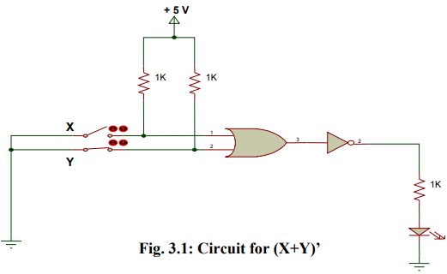

**R.H.S**

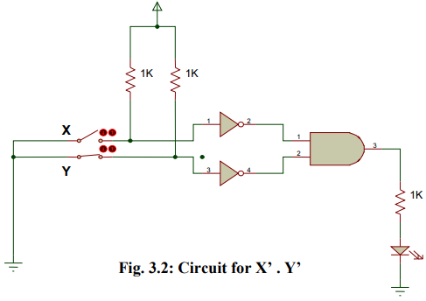

**Truth table:**

|  |  |  |  |  |  |  |
| --- | --- | --- | --- | --- | --- | --- |
| A | B | A' | B' | A+B | (A+B)' | A'.B' |
| 0 | 0 | 1 | 1 | 0 | 1 | 1 |
| 1 | 0 | 0 | 1 | 1 | 0 | 0 |
| 0 | 1 | 1 | 0 | 1 | 0 | 0 |
| 1 | 1 | 0 | 0 | 1 | 0 | 0 |

**Verification of equation (b):**

**Logic circuit diagram:**

**L.H.S**

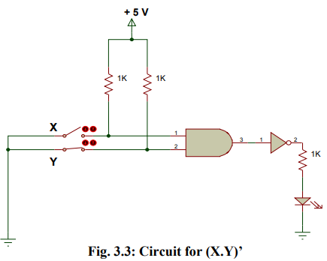

**R.H.S**

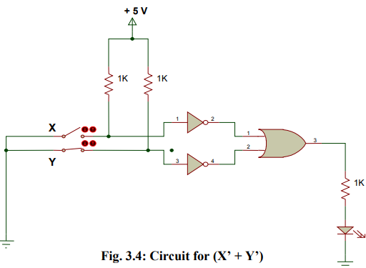

**Truth table:**

|  |  |  |  |  |  |  |
| --- | --- | --- | --- | --- | --- | --- |
| A | B | A' | B' | (A.B) | (A.B)' | A'+B' |
| 0 | 0 | 1 | 1 | 0 | 1 | 1 |
| 1 | 0 | 0 | 1 | 0 | 1 | 1 |
| 0 | 1 | 1 | 0 | 0 | 1 | 1 |
| 1 | 1 | 0 | 0 | 1 | 0 | 0 |

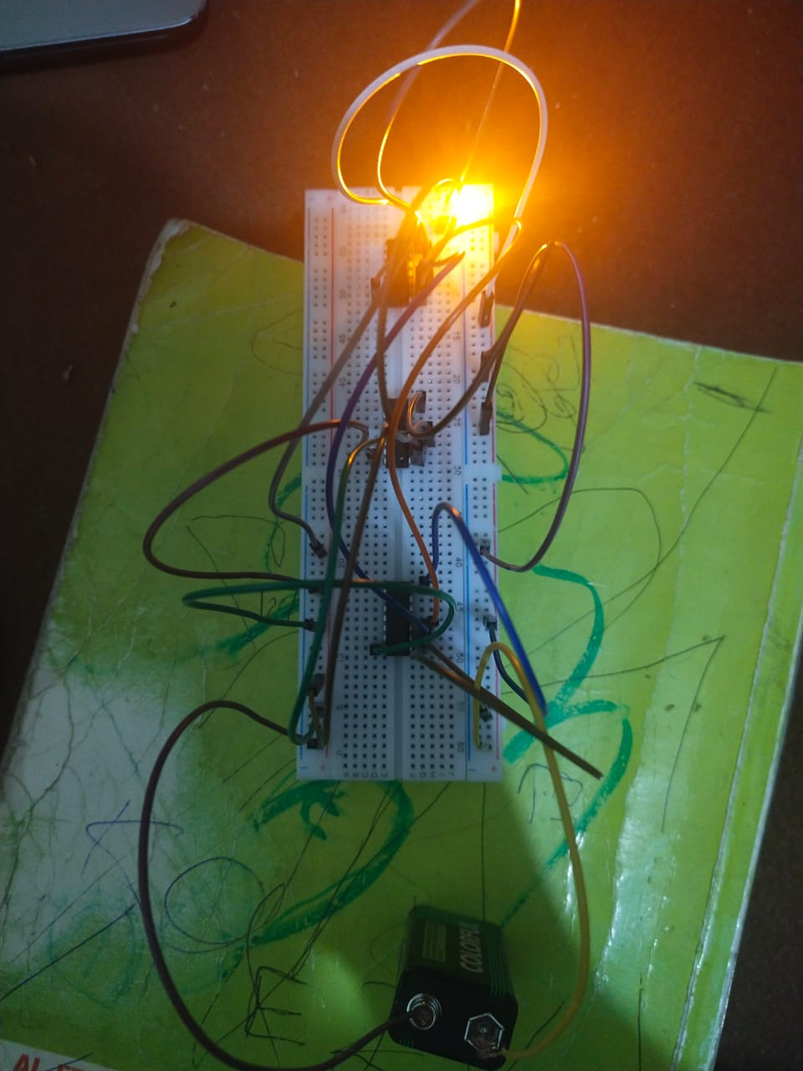

**Real life picture:**

**REVIEW QUESTIONS**

**Q no1:** Simplify the expression using De-Morgan's theorems and verify the two expressions experimentally.

F= ((A . B)’ + A)’

**Answer:**

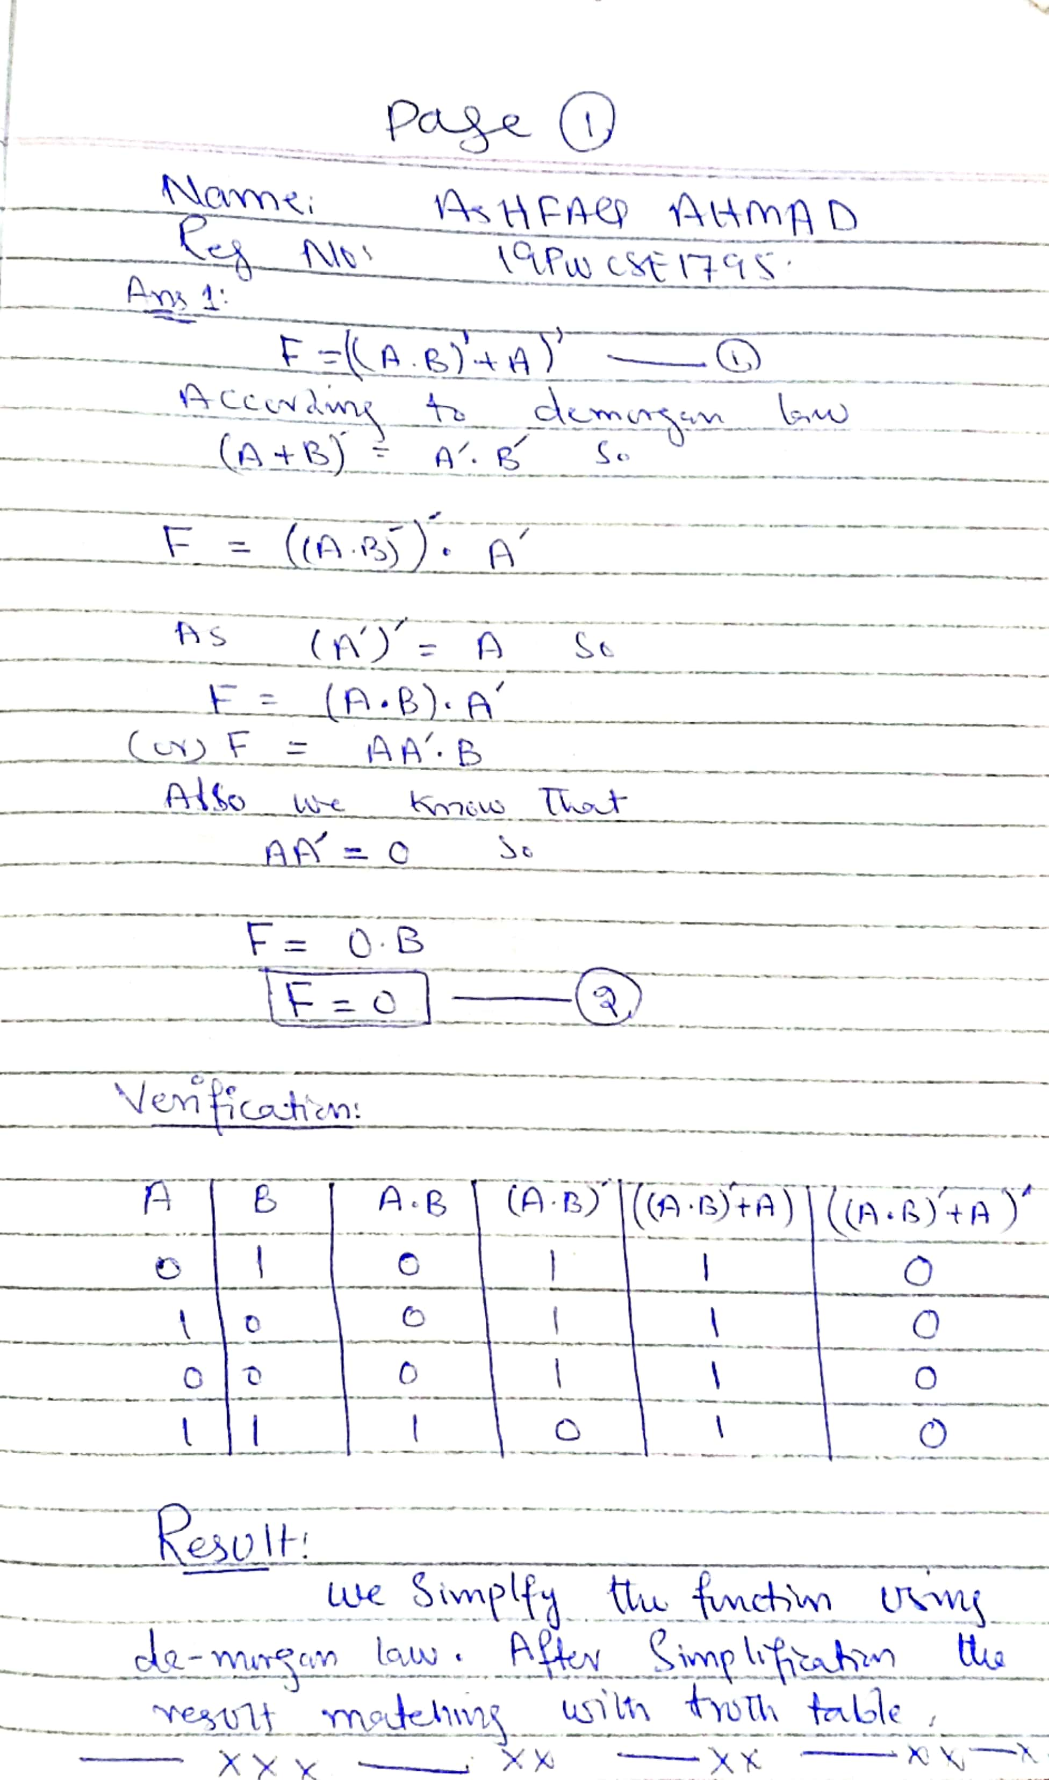

**Q no 2:** Determine experimentally whether the given circuits are equivalent. Then use De Morgan’s theorem to prove your answer algebraically.

**Answer:**

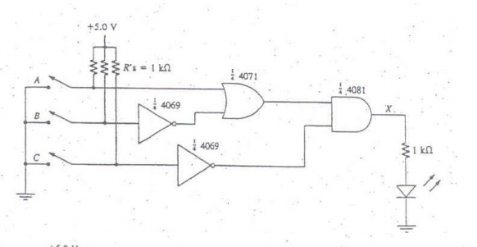

**Circuit 1.**

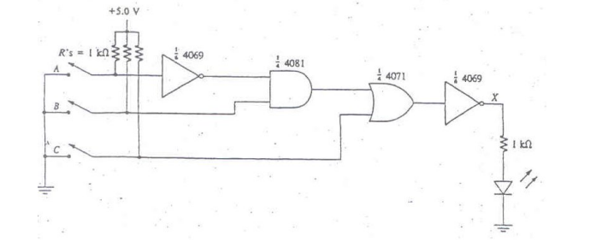

**Circuit 2.**

